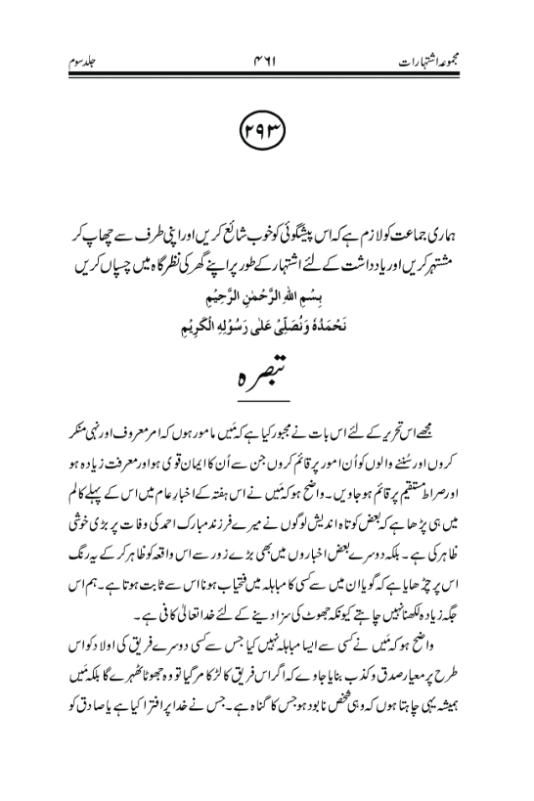
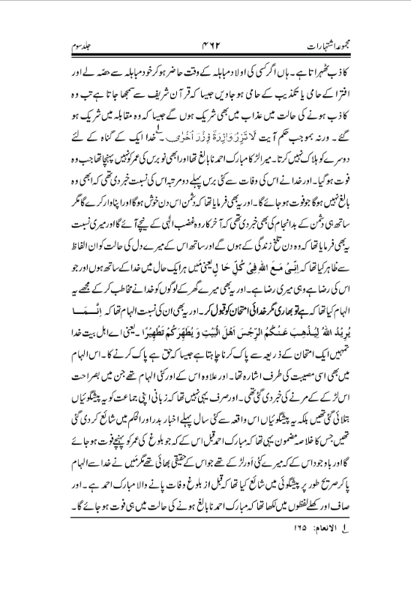
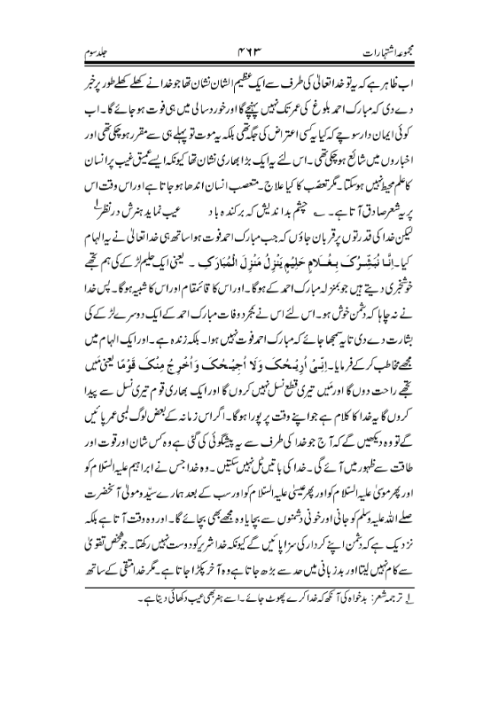
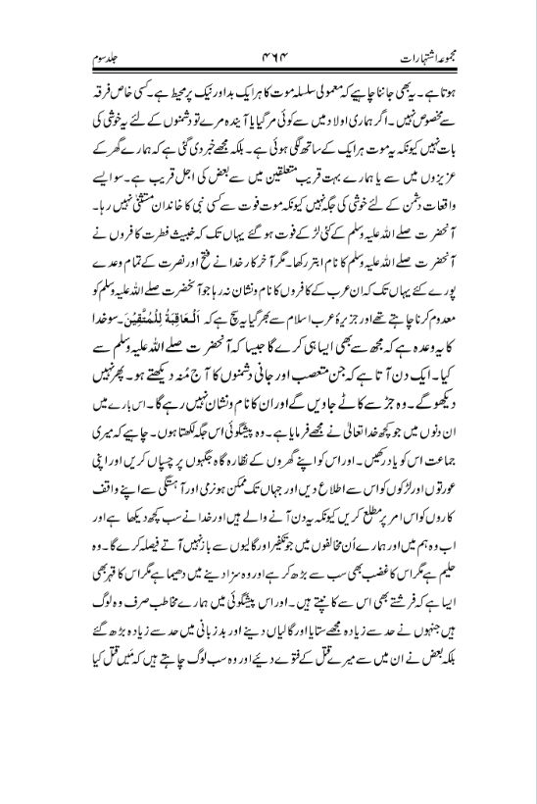
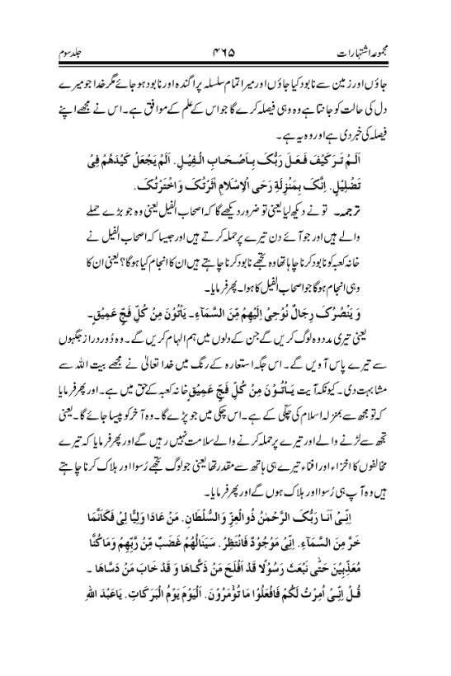
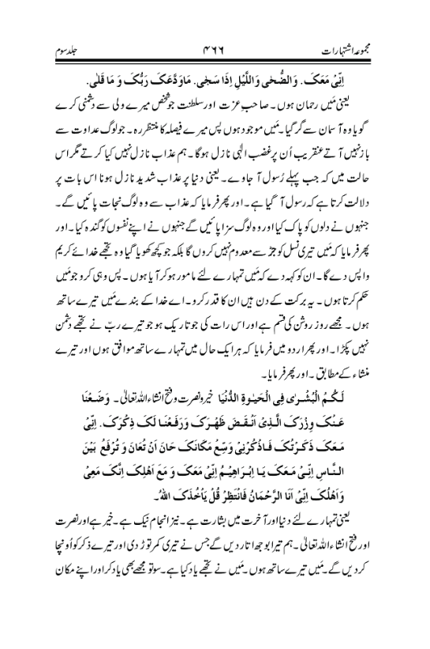
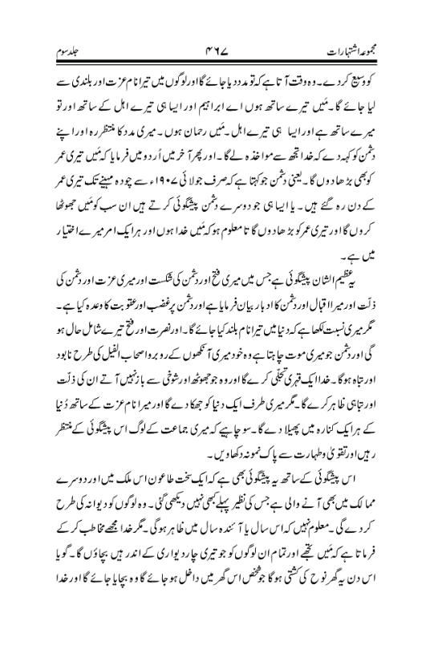

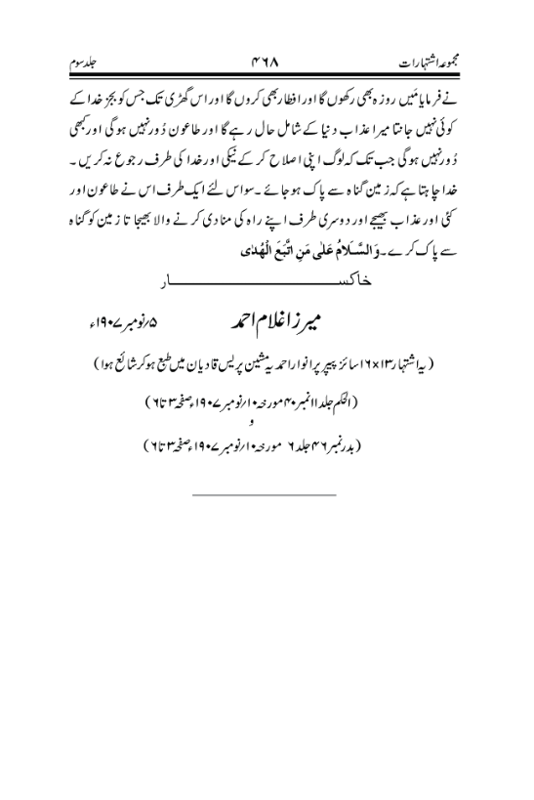
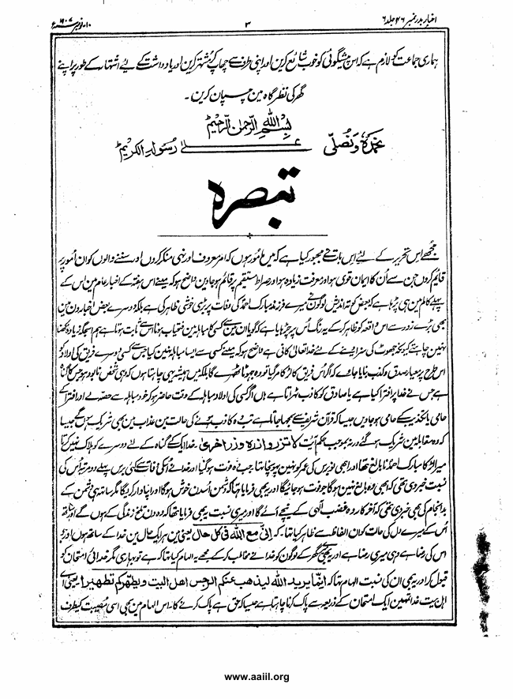
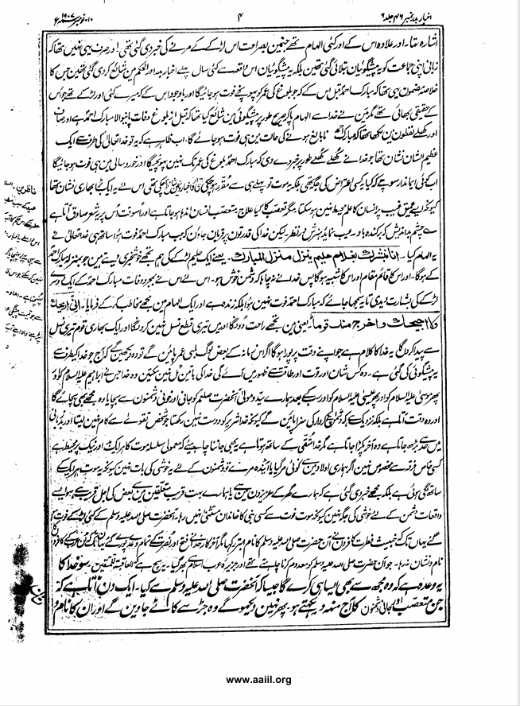
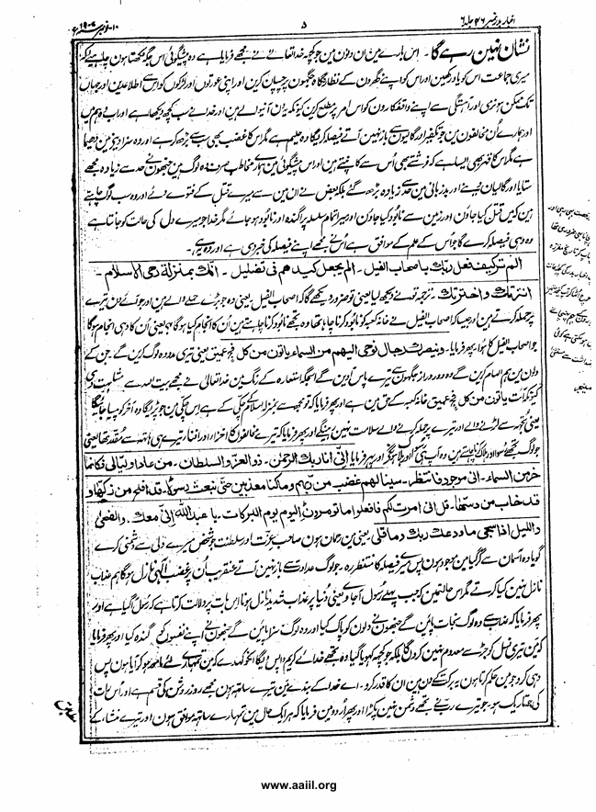
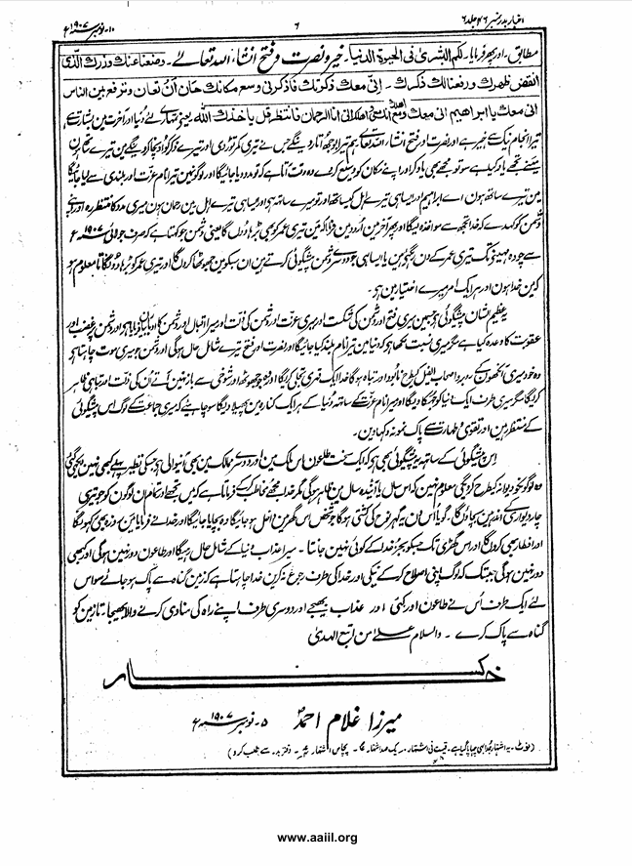
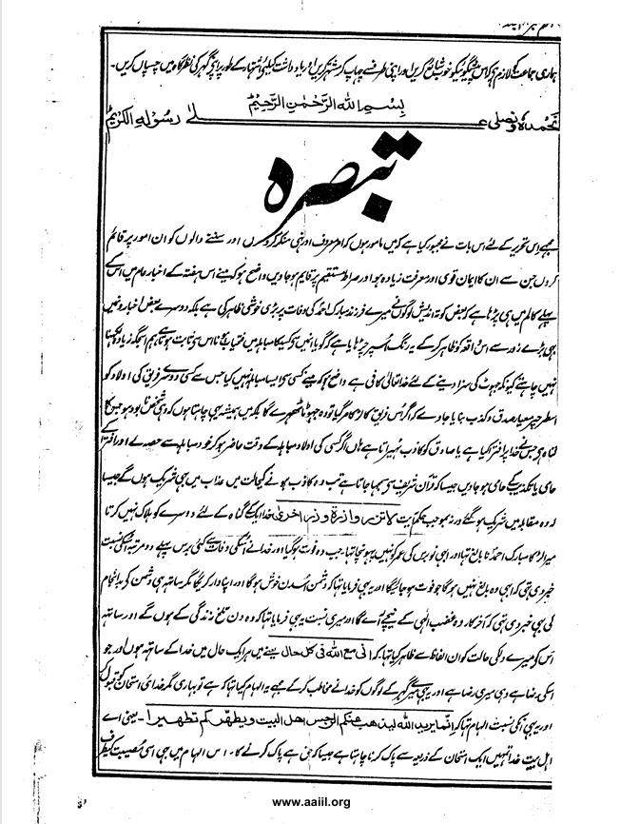

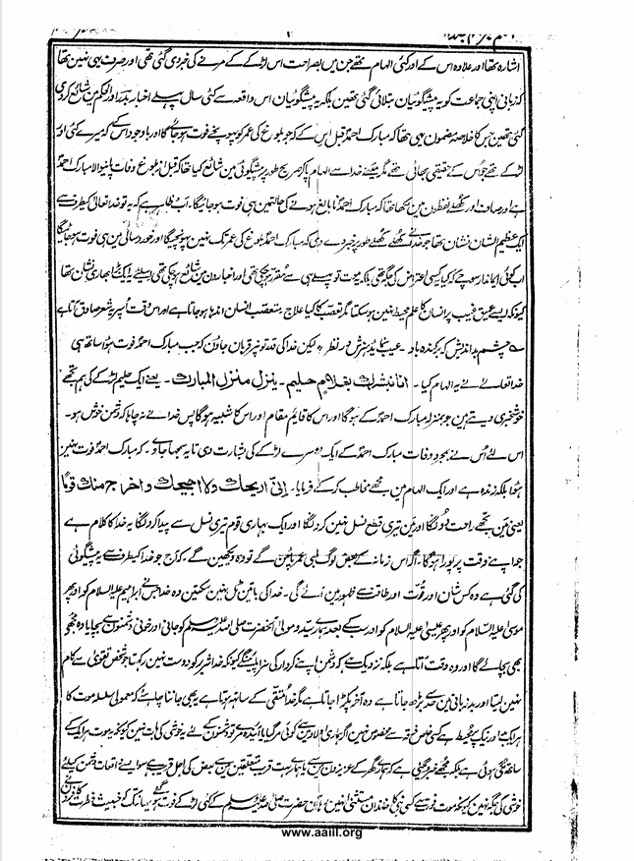
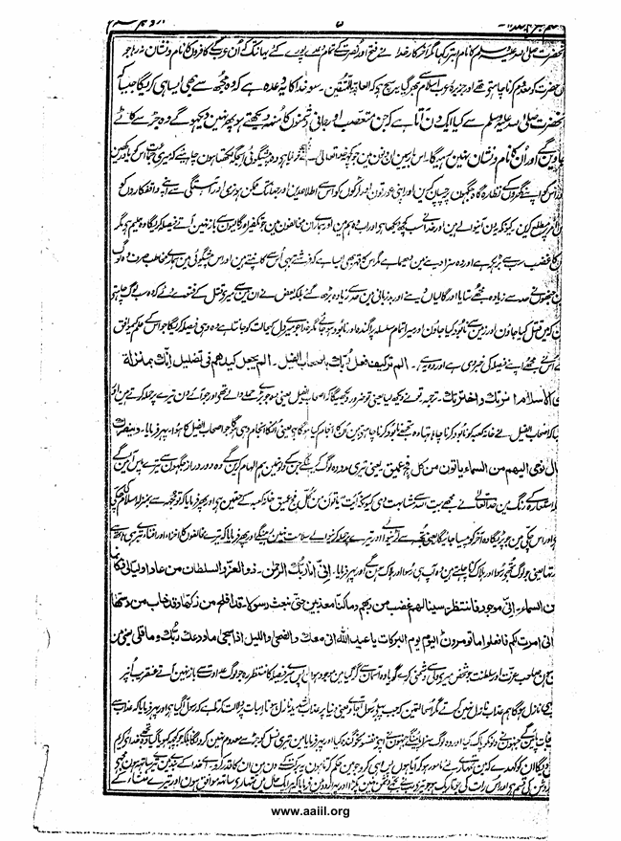
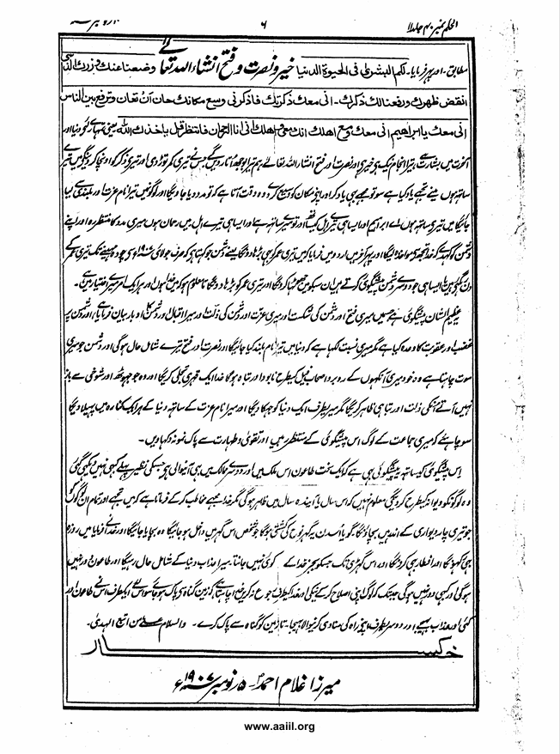
Our community must publish this prophecy well, print it out and advertise it, and post it in the front of their homes as a reminder.
In the name of God, the most gracious, the most merciful
We praise Him and send prayers upon His noble Messenger.
Commentary
I have been compelled to write this article because I am tasked with enjoining what is right and forbidding what is wrong, and to establish the listeners on matters that will strengthen their faith, increase their knowledge, and establish them on the straight path. It should be clear that I have read in the first column of this week's Akhbar-e-Aam that some people who were worried about the death of my blessed son Ahmad have expressed great joy. In fact, in some other newspapers, this incident has been highlighted with great force and given this color to it, as if it proves that one of them has won the Mubahala. We do not want to write much here because God Almighty is sufficient to punish lies.
It should be clear that I have not engaged in such Mubahala with anyone that the children of another party are made the standard of truth and falsehood in such a way that if the son of that party dies, he will be considered a liar, rather I always want that the person whose sin is committed to be destroyed. The one who has slandered God or the one who has lied to the truthful, to be destroyed it is considered a lie. Yes, if someone's children are present at the time of the Mubahila and participate in the Mubahila themselves and become supporters of the slander or supporters of the denial, as is understood from the Holy Quran, then they will also share in the punishment in the state of being a liar, as they participated in the competition. Otherwise, according to the command of the verse: لا تَزِرُ وَازِرَةٌ وِزْرَ أُهْرَ - خدا ) خُرْرَ أَخْرَ. God does not destroy another for the sin of one. Mubarak Ahmad of Miralar was a minor and had not yet reached the age of nine when he died. And God had informed him twice about him many years before his death that he would not yet reach the age of majority who would die. And it had also been said that the enemy would be happy on that day and would attack, but at the same time it had also informed of the enemy's bad fate that he would eventually come under the wrath of God and it had also been said about me that those days would be a bitter life and at the same time it had expressed the state of my heart with these words: انسى مَعَ اللهِ فِي كُلِّ حَالِ, meaning I am with God in every situation and whatever pleases Him is my pleasure. And it was also addressed to the people of my family by God and inspired me that it is difficult but accept the divine test. And this was also the revelation regarding them: "Allah only wants to remove impurity from you, O people of the House, and to purify you with a purification." That is, O people of the House, Allah wants to purify you through a test, as is the right of purification. This revelation also referred to this calamity. And apart from this, there were many other revelations in which the news of the death of this boy was explicitly given. And it was not only that these prophecies were conveyed to my community orally, but these prophecies were published in the newspapers Badr and Al-Hakam many years before this event, the summary of the article being that Mubarak Ahmad would die before reaching the age of puberty, and despite the fact that I had several other sons who were his real brothers, I had received inspiration from God and had explicitly published the prophecy that the one who would die before puberty was Mubarak Ahmad. And it was written in clear and open words that Mubarak Ahmad would die while still a minor. Now it is clear that this was a great sign from God Almighty, which God openly announced that the blessed Ahmad would not reach puberty and would die in infancy. Now a believer should think whether this was a place for any objection, rather this death had already been determined and had been published in the newspapers. Therefore, this was a great sign because human knowledge cannot encompass such a profound unseen. But what is the cure for prejudice? A prejudiced person becomes blind and at that time this verse comes true for him.
The evil eye will be cut off.
But I submit to the powers of God that when the blessed Ahmad died, God Almighty revealed this revelation. We give you the good news of a knowledgeable boy who will descend to the blessed abode - that is, we give you the good news of a knowledgeable boy who will be like the blessed Ahmad. And he will be his successor and his image. So God did not want the enemy to be happy. Therefore, He gave the good news of another son of the blessed Ahmad, so that it would be understood that the blessed Ahmad did not die. Rather, he is alive. And in a revelation he addressed me and said: I will give you rest and I will not cut off your descendants and I will make a great nation from you. This is the word of God which will be fulfilled in its time. If some people of this era live long enough, they will see that this prophecy made by God today will manifest with some glory and power and might. The words of God cannot be found. The God who saved Abraham (peace be upon him), then Moses (peace be upon him), then Jesus (peace be upon him), and finally our master and master, the Holy Prophet (peace be upon him), from deadly and bloody enemies, will also save me. And that time is coming, indeed it is near, when the enemies will be punished for their actions because God does not love the wicked. The person who does not act with piety and goes beyond limits in bad language will eventually be caught. But God is with the pious. It should also be known that the ordinary series of deaths encompasses both the good and the bad. It is not specific to any particular sect. If one of our children has died or is about to die, it is not a matter of joy for the enemies because this death is attached to everyone. Rather, I have been informed that the death of some of our dear family members or our very close relatives is near. Such incidents are not a place of joy for the enemies because the family of any prophet was not exempt from death. Many sons of the Holy Prophet (peace and blessings of Allah be upon him) died, to the extent that the wicked infidels named the Holy Prophet (peace and blessings of Allah be upon him) as Abtar. But in the end, God fulfilled all the promises of victory and victory until the name and trace of those Arab infidels who wanted to destroy the Holy Prophet (peace and blessings of Allah be upon him) were no more and the Arabian Peninsula was filled with Islam. It is true that the consequence is for the righteous - so God has promised that He will do the same to me as He did to the Holy Prophet (peace and blessings of Allah be upon him). A day will come when the faces of those fanatic and mortal enemies that we see today will not be seen again. They will be uprooted and their name and trace will not remain. I am writing down what God Almighty has told me in these days about this. That prophecy. My group should remember it. And paste it in the visible places of your houses and inform your women and boys about it and as much as possible gently and gently inform your acquaintances about this matter because these days are coming and God has seen everything and now He will judge between us and those of our opponents who do not desist from takfir and abuse. He is gentle but His anger is also greater than all and He is slow to punish but His anger is also such that even the angels tremble from it. And in this prophecy, our addressees are only two people who persecuted me to the limit and went to the limit in abusing and bad language, rather some of them gave fatwas to kill me and they all want me to be killed. I may go and be destroyed from the earth and my end may be scattered and destroyed, but God, who knows the state of my heart, will decide what is in accordance with His knowledge. He has informed me of His decision, and this is it.
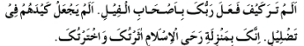
Translation: You have seen, that is, you will certainly see that the Companions of the Elephant, that is, those who are of great aggression and who attack you on a daily basis, and just as the Companions of the Elephant wanted to destroy the Kaaba, they want to destroy you. What will be their end? That is, their end will be the same as the Companions of the Elephant. Then he said:
That is, those in whose hearts We inspire will help you. They will come to you from faraway places. In this place, God Almighty has likened me to the House of Allah in metaphorical terms. Because the verse يَأْتُونَ مِنْ كُلِّ فَجٍّ عَمِيقَّ is in favor of the Kaaba. And then He said, You are like the millstone of Islam to me. Whatever falls into this millstone will be ground in the end. That is, those who fight with me and attack you will not be safe. And then He said, The disgrace and the verdict of your opponents were destined by Your own hand, that is, those who want to disgrace and destroy you will themselves be disgraced and destroyed. And then He said,
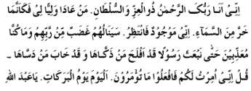
That is, I am the Most Gracious. The owner of honor and power, whoever shows enmity to my guardian, it is as if he has fallen from the sky. I am present, so wait for my decision. Those who do not desist from enmity, the wrath of God will soon descend on them. We do not send down punishment except when a messenger comes first. That is, the severe punishment descending on the world indicates that a messenger has come. And then he said that those who will be saved from the punishment. Those who purified their hearts and those who defiled their souls will be punished. And then he said that I will not eradicate your offspring from the root, but what was lost, God will return to you. Tell them that I have come on a mission for you. So do what I command. These are blessed days, cherish them. O servant of God, I am with you. I swear by the bright day and by the dark night that your Lord has not taken you as an enemy. And then he said in Urdu that I am with you in every situation and according to your desire. And then he said.
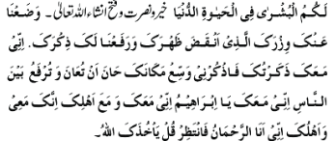
That is, there is good news for you in this world and the Hereafter. And the end is good. There is goodness and victory and victory, God willing. We will remove your burden that has broken your back and will raise your remembrance. I am with you. I have remembered you. So remember Me and return to your home. Expand. The time is coming when you will be helped and your name will be taken with honor and exaltation among the people. I am with you, O Abraham, and so with your family, and you are with me, and so with your family. I am the Most Gracious. Wait for my help and tell your enemy that God will take action against you. And then at the end he said in Urdu that I will also extend your life. That is, the enemy who says that only fourteen months from July 1907 are left for your life. Or similarly, I will refute all the other enemies who prophesy and extend your life so that it will be known that I am God and that every matter is in My control.
This is a great prophecy in which my victory and the defeat of the enemy, my honor and the humiliation of the enemy, my success and the respect of the enemy have been described, and wrath and punishment have been promised to the enemy. But it has been written about me that your name will be exalted in the world. And victory and victory will be yours, and the enemy who wants my death will be destroyed and annihilated before my eyes like the companions of the elephant. God will manifest a wrathful manifestation and will show the humiliation and destruction of those who do not desist from lying and joking. But He will incline a world towards me and spread my name with honor to every corner of the world. So the people of my community should wait for this prophecy and show an example of piety and purity.
Along with this prophecy is the prophecy that a severe plague is coming to this country and to other countries, the like of which has never been seen before. It will drive people crazy. It is not known whether it will appear this year or next year. But God addresses me and says that I will save you and all those who are within your walls. It is as if this house will be Noah's ark on that day. Whoever enters this house will be saved and God will save him. He said, "I will fast and break my fast, and my punishment will remain with the world until an hour that no one knows except God, and the plague will not go away, and it will never go away until people reform themselves and turn to goodness and God. God wants the earth to be cleansed of sin. So on one hand, He sent plagues and many other punishments, and on the other hand, He sent a herald of His way to cleanse the earth of sin. And peace be upon those who follow the guidance.
خاکس
Mirza Ghulam Ahmad 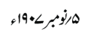
(Al-Hikam, Volume 1, Number 40, Dated November 10, 1907, Pages 3 to 6)
(Badr No. 46, Volume 6, Dated November 0, 1907, Pages 3 to 6)
All the translations were done with the help of Google lens.

